T.F. SOUTH

CLASS OF 1971

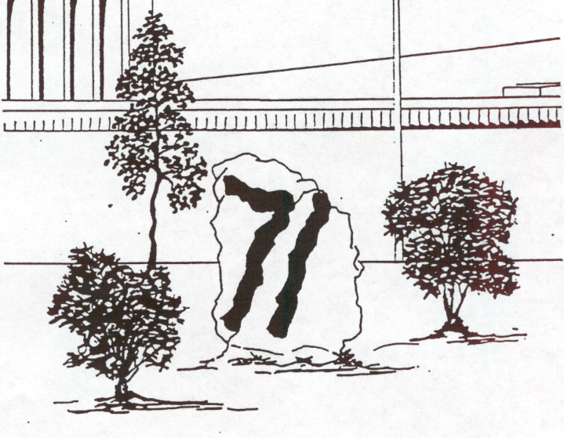

50-year Class Reunion

October 2, 2021
50-year Class Reunion
Class of 71
Center for Visual and Performing Arts
Munster IN

Registration 5:30 pm
Class Picture and Opening Welcome 6:30
Conversation, Food, Music, Dancing 7-11

Post-reunion partying (the ‘after prom’ party!) continues at Jack’s Place if you can stay awake!

The Reunion Committee

Debbie Bauer Senffner, Scott Malcom, Mark Valco, Lynda Willer, Luann Knoerzer Malark, Theresa Pasquarella (with Pamn Grieve Baker, Karen Wall Brenner, Melinda Stinnett and Cindy Twardosz Finley).
Please keep in touch with any email change lyndawiller@comcast.net)
Stay Connected: Class of 71 website (maintained by Mark Valco): http://tfs71.com/reunion.htm
Class of 71 group on Facebook, information posted on alumni site of TF South, and messages posted via Classmates.com

The Class of 1971

Senior Class Officers

President: Scott Malcom
Vice-President: Kathryn Kreps
Secretary: Debbie Bauer
Treasurer: Mike Toepher

Class Gift: Spirit Rock & Landscaping
Class Colors: Red, Gray, White
Class Flower: Daisy
Class Motto: No man is free until he has mastered himself

Spirit Rock Artwork by Ken Jordan

William Albrecht
Jan Ambry Jerde
Debbie Bauer
Linda Bauer
Compton
Jeff Biel
Barb Bogus
Al Broomhead
Doug Carr
Darlene Broza
Carter
Nancy Carlson
Wojcik
Janet Darlington
Stinson
Marilyn Ditter
Olsen
Wally Emlund
Stephen Felle
Linda Franklin
Kelley
Barbara Gardner
Burgess
Rich Gjeldum
Tom Gosciej
Pamn Grieve
Baker
Glenn Gustafson
Duane Hansen
Bill Hastings
Terry Hektoen
Tim Hektoen
ATTENDEES
Deborah
Hockenberry
Fritz
William Homan
Denise Hutchison
Maravilla
Ken Jordan
John Junker
Rich Kelley
Jeff Kiester
Jeff Kowalczyk
Bob Krilich
Diane Labahn
Scanlon
Tom Madix
Edith Ann Marich
Stratis
Scott Malcom
Larry Mlynarcik
Don Olsen
Robert Oswalt
Richard Parker
Theresa
Pasqaurella
Ken Rahn
Sabena Ramanna
Poore
Gary Rathbone
Ron Relic
Jayme Rice
Cindy Schroeter
Biederstadt

David Schumann
Roberta Sell
Diane Sheppard
Stooksbury
Wayne Simmons
Anita Smith
Laurel Smith
Bartels
Ron Snyder
Ralph Spargo
Rick Stinson
Ron Sylvester
Mike Toepher
Cynthia Twardosz
Finley
Mark Valco
Kathy Visnack
Spargo
Nicolette Wagner
Borys
Craig Walker
Karen Wall
Brenner
Deborah Watson
Lynda Willer
Mark
Wojciehowski
John Wollack
Joyce Yellina
Dittmer
Don Zebrauskas
Egon Zimmerman

